Dispatcher -Carrier Agreement BASIC PACKAGE
This Agreement is made this day of , 20 , by and between "STLI DISPATCHER , hereafter referred to as DISPATCHER, and , Hereinafter
referred to as CARRIER. WHEREAS DISPATCHER is a transportation dispatcher handling the necessary paperwork between a SHIPPERS and the CARRIER in order to secure "CARGO" for said CARRIER.

WHEREAS CARRIER is a Motor CONTRACT Carrier subject to the jurisdiction of the ICC: NOW, THEREFORE, in consideration of the promises and convents hereinafter contained It is mutually agreed by and between parties hereto as follows:
OBLIGATIONS OF DISPATCHER
- DISPATCHER agrees to handle paperwork, phone, fax calls to, from the SHIPPER to tender commodities shipments to CARRIER for transportation in interstate commerce by CARRIER between points and places within the scope of CARRIER'S operating authority.
- DISPATCHER bears no financial or legal responsibility in the transaction between the SHIPPER, CARRIER agreement. OBLIGATIONS OF CARRIER
- CARRIER agrees to pay DISPATCHER percent (see below%) of the face value of the contract between the SHIPPER, CARRIER as stated on the load confirmation sheet. Carrier further agrees to pay DISPATCHER at time of securing cargo.
- CARRIER gives DISPATCHER authority to provide his signature for rate confirmation sheets, invoices and associated paperwork necessary for securing cargo and billing purposes. The terms of this agreement shall be perpetual, provided that either party may terminate same by giving 30 days written notice to the other.
- SHIPPER agrees to pay CARRIER promptly, following receipt of a freight bill and proof of delivery of each shipment to its assigned destination, free of damage or shortage. The amount to be paid by SHIPPER to CARRIER shall be established between parties on a per shipment basis prior to commencement of each individual shipment. A load confirmation including details of shipment and revenue tto be paid will be supplied via FAX by SHIPPER to CARRIER. Confirmation will be signed by DISPATCHER and returned via FAX to SHIPPER.
- CARRIER shall be liable for loss, damage, or liability occasioned by the transportation of property arranged by DISPATCHER, SHIPPER while in the possession of carrier.
- CARRIER agrees to hold DISPATCHER, SHIPPER harmless from any liability for personal injury or property damage occurring during operation conducted by CARRIER pursuant to this agreement.
- CARRIER will be responsible to comply with all applicable state and federal regulations pertaining to the operation of a motor carrier.
- CARRIER and DISPATCHER agree that DISPATCHER, at great expense, has developed a broad customer base of shippers, receivers, and brokers that is essential to the successful operations of his company. CARRIER and DISPATCHER agree that disclosure of the identity of one or more of the companies said customers to CARRIER constitutes valuable consideration. During the term of this AGREEMENT and for a period of two (2) years from its termination, CARRIER shall not, directly or indirectly, solicit or do business years from its termination, CARRIER shall not, directly or indirectly, solicit or do business involving transportation or of a warehousing nature with any the companies’ customers who are serviced by CARRIER as a result of this AGREEMENT unless otherwise agreed by the parties in writing.
- Carrier acknowledges that the customer information being provided by DISPATCHER is the sole and exclusive property of DISPATCHER and that neither it, nor any employee, agent, or subcontractor shall back-solicit, directly or indirectly, communicate or perform any service for compensations for any account of DISPACTCHER which has previously tendered to CARRIER for
transportation, nor shall it pass on or reveal any customer information obtained to any other person or company. .
- Solicitation prohibited under this AGREEMENT means participation in any conduct, whether direct or indirect, the purpose of which
involves transportation and/or handling of property by CARRIER for which CARRIER does, or did in the past, provide such service for that customer under arrangements first made or procured by DISPATCHER. Solicitation includes conduct initiated or induced by CARRIER, or accepted by CARRIER, upon inducement by DISPATCHER efforts.
- If CARRIER should perform services of a transportation or warehousing nature for compensation for any DISPATCHER customer without prior documented authorization from DISPATCHER during the applicable time period in violation of this AGREEMENT, CARRIER shall pay to DISPATCHER within seven (7) days of each such violation an amount equal to (10%) of all revenues invoiced by CARRIER to the solicited customer. Where a dispute or disagreement arises, both parties agree to tender the issue to binding arbitration in the "State of Your State".
- CARRIER acknowledges that a breach of this provision will give rise to immediate and Irreparable injury to DISPATCHER, which Is inadequately compensated in damages. Accordingly, CARRIER agrees that DISPATCHER Is entitled to obtain injunctive relief against the breach or threatened breach by CARRIER of this obligation, in addition to any other legal remedies, which may be available. CARRIER further acknowledges that the precise damages DISPATCHER would sustain out of any breach of this covenant may be difficult to ascertain and agrees that it shall pay as damages, twenty-five (25%) percent of the aggregate of all rates and charges

assessed by CARRIER for transportation services provided to any account of DISPATCHER that Is handled in contravention of this agreement, plus liquidated damages of ten thousand ($10,000.00) dollars.

- CARRIER agrees that it will function under terms of this agreement strictly as duly permitted contract carrier, and hereby waves any and all rate provisions, which may be contained In Its published carrier tariffs.

- This agreement shall be deemed to be effective on the first date that CARRIER, DISPATCHER, and SHIPPER commence business together, and the parties hereby agree that the provisions herein properly express and memorialize the complete understanding as contained in any prior agreement either written or verbal.

STLI DISPATCHER
BY: STLI (RICK )
TITLE: Operations Manager

DATE:

CARRIER:

BY:
TITLE: --
DATE:

LIMITED POWER OF ATTORNEY
KNOW ALL MEN BY THESE PRESENTS that I of

-------------' hereby make, constitute, and appoint STLI DISPATCHER as my true and lawful attorney in fact for me and in my name, place, and stead, for the following purposes only:
- To transfer documents
· Accept loads
- Discuss my accounts and invoice customers
- Modes of communication for requesting and receiving information may include telephone, email, fax or mail

Name: Signature:

Date:
-----'
I I -

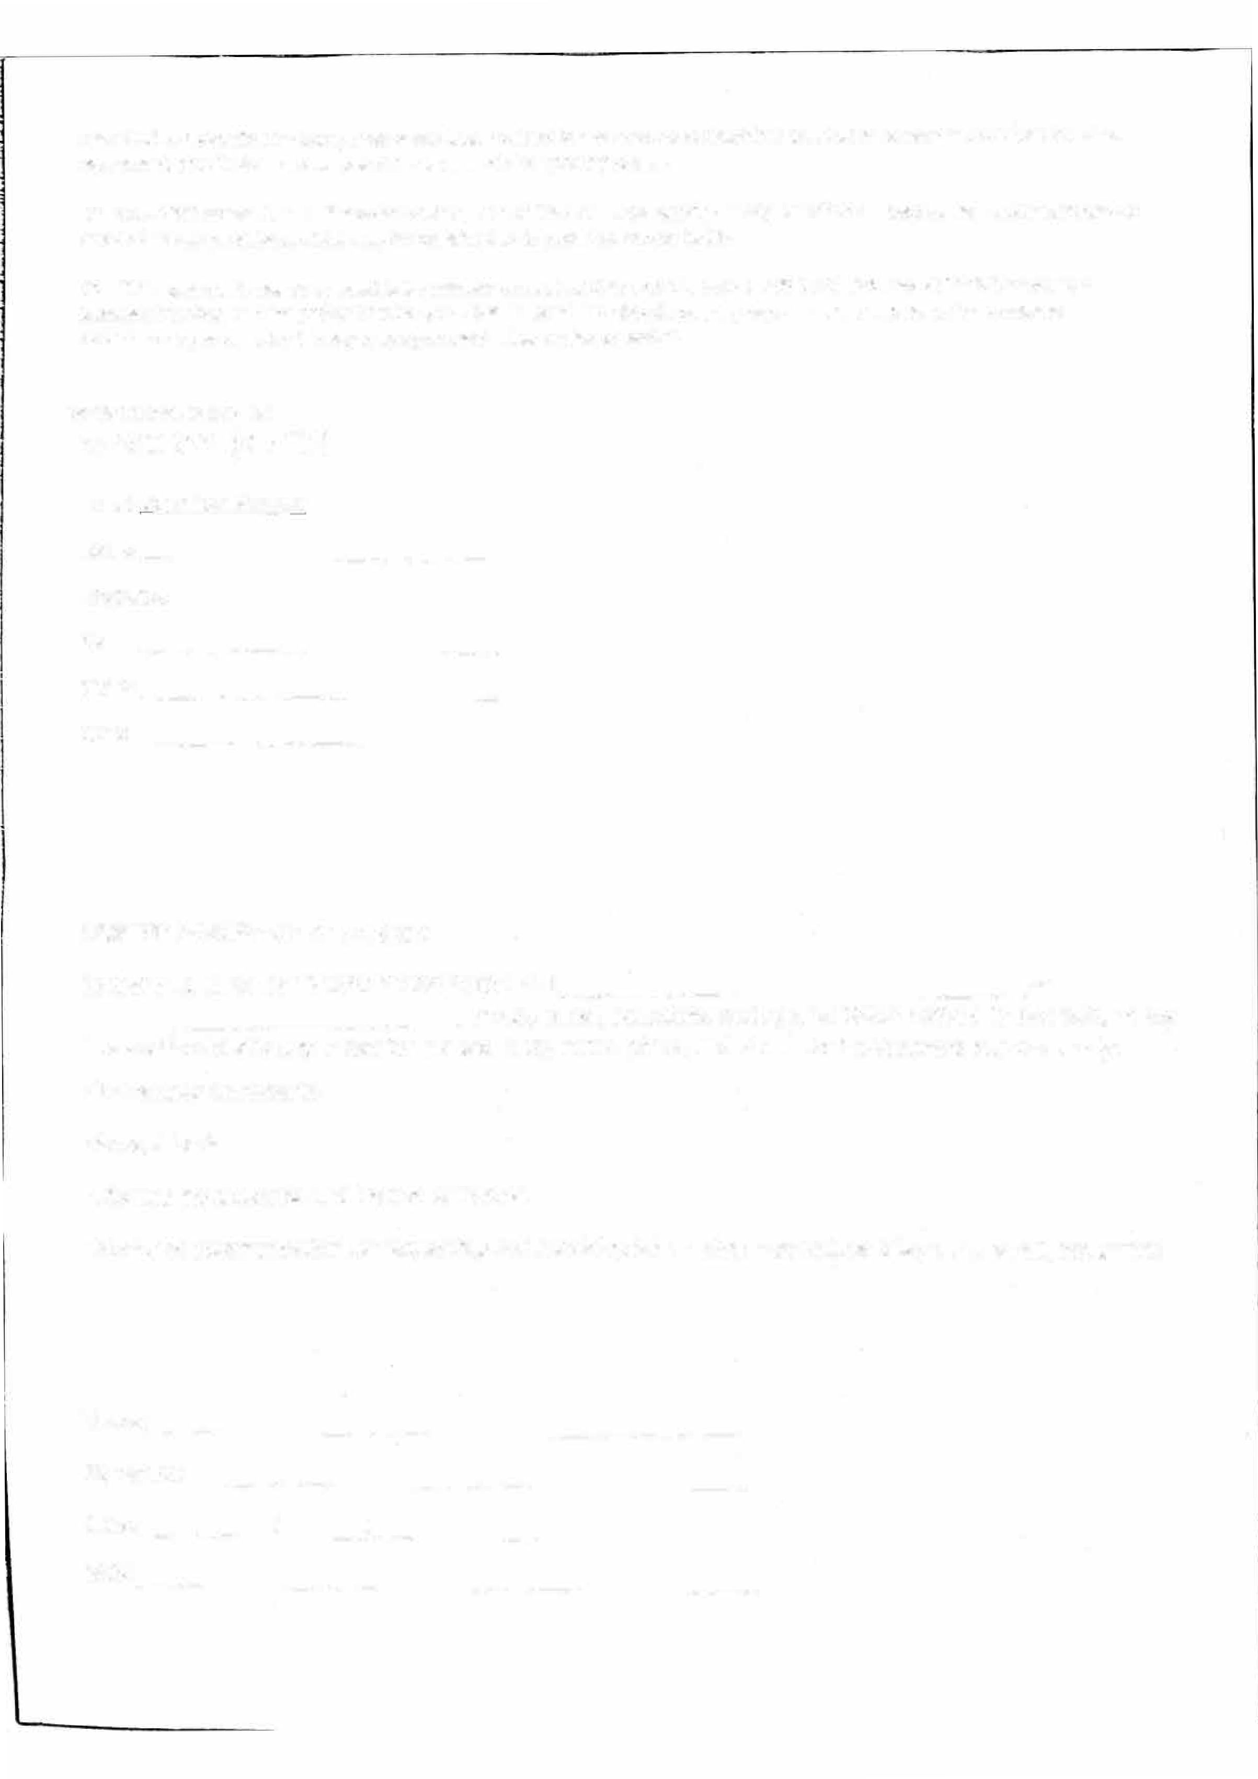
MC#

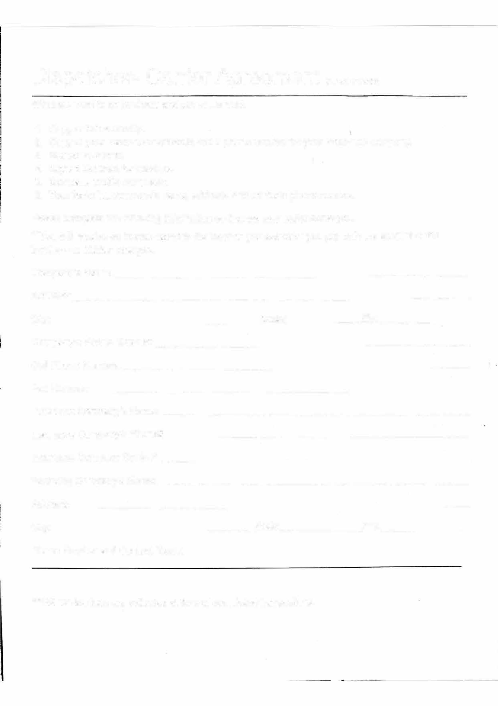
Dispatcher- Carrier Agreement (Fill out OR print)
What we need to do business and get you a load.

- Copy of MC Authority.
- Copy of your insurance certificate and a phone number for your insurance company.
- Signed W-9 form.
- Signed Contract for services.
- Company profile completed.
- Your factoring company's name, address, and contacts phone number.

Please complete the following information so that we may better serve you.
**You will receive an invoice faxed to the location you selected; you pay only the amount of the invoice -no hidden charges.
Company's Name: _ _
Address: _ City:_ _State: Zip: _
Company's Phone Number:
Cell Phone Number: _
Fax Number: _ _
Insurance Company's Name: _
Insurance Company's Phone#
Insurance Company Contact: _
Factoring Company's Name: __
Address: _ City: _ _State: Zip: _
Phone Number and Contact Name:

***All service fees are collected at time of completed transactions.
BASIC PACKAGE FEES INCLUDE DISPATCHING FEE 6.95% OF ENTIRE LOAD OR LOADS PAID TO STLI ECHECK OR ZELLE PAYMENT ONLY. A MONTHLY CARRIER FEE $59.99 (PAYAL AUTO, OR DEBIT AUTO THIS IS A MONTHLY DEBIT ON DATE THIS CONTRACT IS SIGNED), THIS PK INCLUDES DISPATCHING AND CUSTOMER SERVICES NEEDS CONCERNING LOADS. ALL CARRIES IS RESPONSIBLE FOR BILLING/INVOICING AND FOR TAX PREPARATION.

